Ean Masoner

Module 3.2 Assignment

CSD-340

HTML Validation

CSS Validation

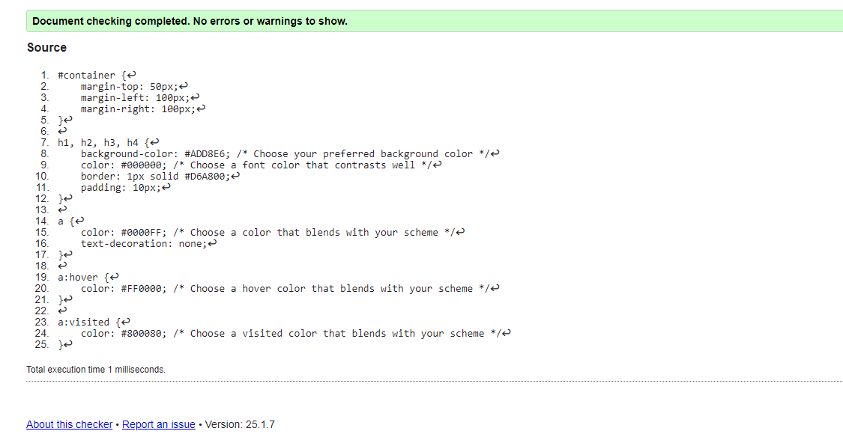

Browser Output ScreenShot

